Exercise – 4

1. Verify if master is in clean state.

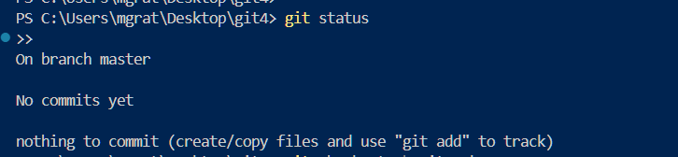

1. Create a branch **“GitWork”.** Add a file “hello.xml”.

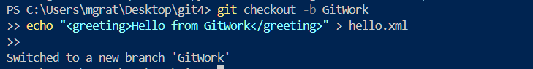

1. Update the content of “hello.xml” and observe the status

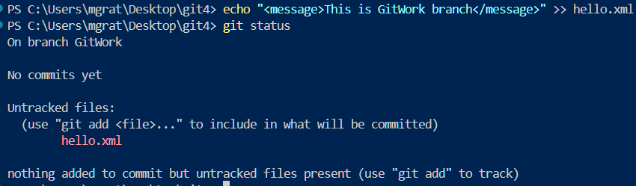

1. Commit the changes to reflect in the branch

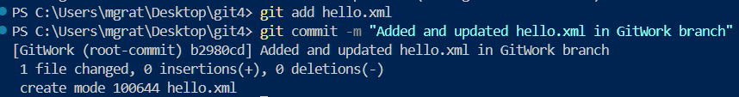

1. Switch to master



1. Add a file **“hello.xml”** to the master and add some different content than previous.



1. Commit the changes to master

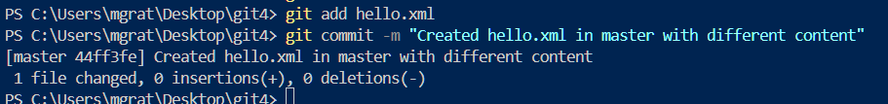

1. Observe the Git log graph

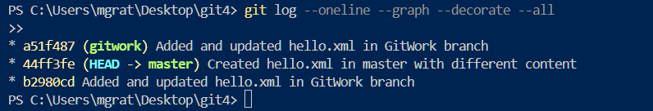

1. Check the differences with Git diff tool

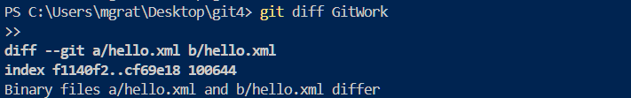

1. **Use P4Merge tool (Optional for visual diff)**

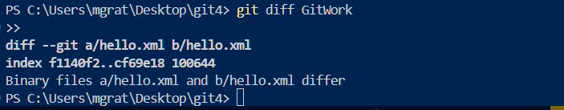

1. **Merge the branch into master (will cause conflict)**

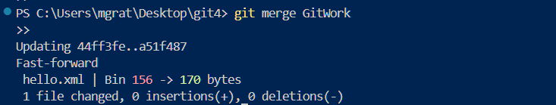

1. Observe the Git markup

<<<<<<< HEAD

<greeting>Hello from Master</greeting>

<note>Changes made in master</note>

=======

<greeting>Hello from GitWork</greeting>

<message>This is GitWork branch</message>

>>>>>>> GitWork

1. Use 3-way merge tool (like P4Merge)



1. Commit the resolved file

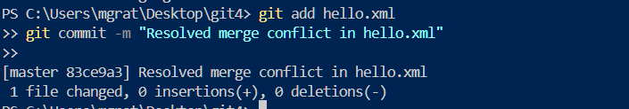

1. Observe status and ignore backup files

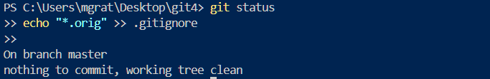

1. Commit the .gitignore change

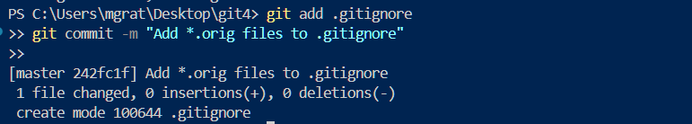

1. List all branches

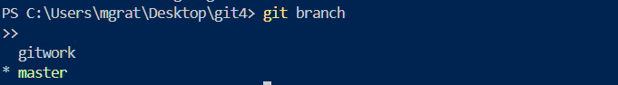

1. Delete the merged branch



1. Observe the final git log

